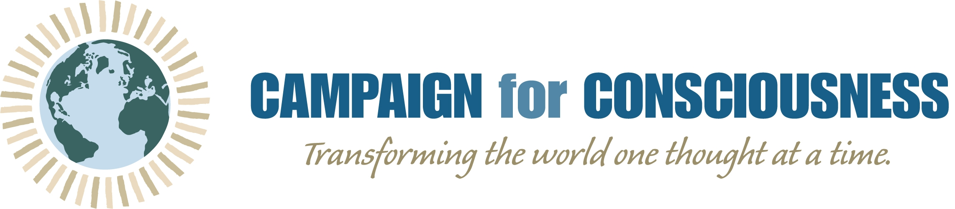

We believe in the power of communication. How we live our lives sends a message. Our words and our silence speak volumes.

Courageously, we practice deep, critical and curious self-reflection. Through honest inquiry, we inventory how we impact our world.

May we be wise, mindful and aware. May our awareness be the salve that heals. May our lives be of benefit to all.

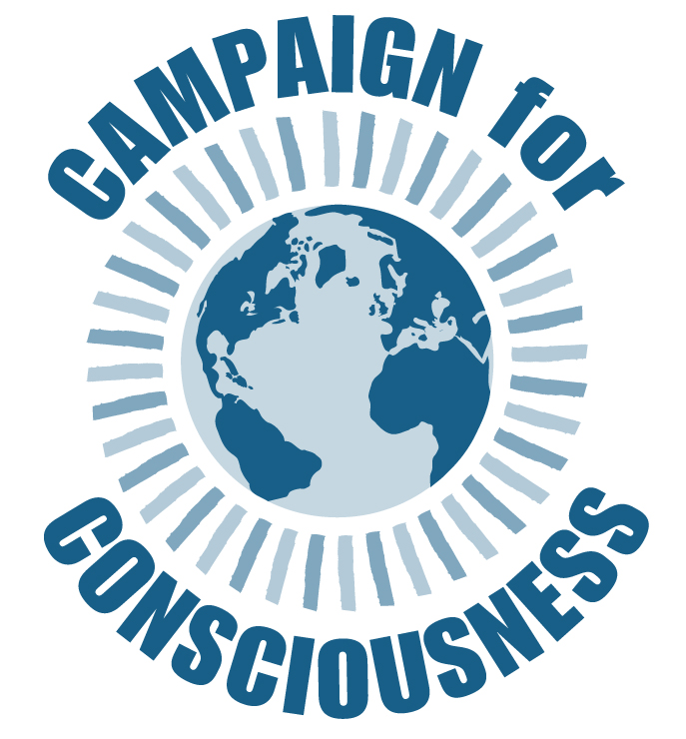
2021 Vision:
To demonstrate wisdom in our communications, mindfulness of our shortcomings, and awareness of our impact. We inventory the quality and impact of communication in our lives and in our world.

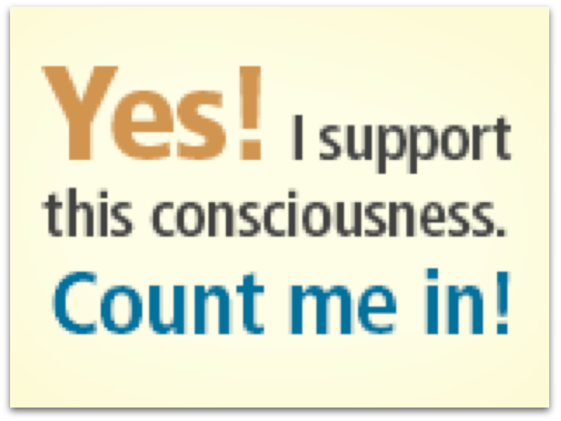
Daily Affirmation for Global Transformation
September 10–October 19

Facebook/Campaign for onsciousness

